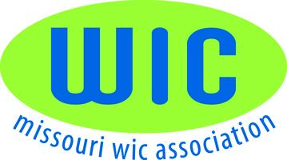 E-mail Minutes of June 4, 2014

An E-mail was sent to voting Members June 4th:
Rhonda Breitenbecher, Acey Staples, Jan Glaze, Margie Beckmann, Cheryl Nelson, Deb Cullum,
Erin Harris, Heidi Loecke, Tammy Drake and Amy Calico.

Below are the three website options/proposals Brenda Brewer and Darla Ketchum collected as requested. Options were referred by Amy Calico, Suzanne Ball and TMC for an update/rebuild of the current MWA website. Board Members were to look at each of the links of each of the three options listed below. Below is three items to keep in mind of the needs of our website
- CONTENT MANAGEMENT system that allows MWA members with Admin Rights to do make text edits and additions, add photos and documents etc to the website.

- CONFERENCE REGISTRATION option that collects attendee information with the ability to print invoices to send payment, we would not be collecting online payments

- MEMBERSHIP INFORMATION that is password protect by member so they can update contact information.

Rhonda Beitenbecher, President of the MWA, asked that each member vote on the vote icon in the upper left corner of the email and select from the drop down the option you feel meets the needs for the website. E-mail votes were sent to Margie and Rhonda for the official count. If you have any questions, please contact Darla or Brenda.

OPTION 1:
- Paul Hochhalter
- Creatives Unleashed
- 636.734.5681
- $7,500. To build
- MWA members to maintain updates
- www.familycarehealthcenter.org

OPTION 2:
- Charlie Steward
- 417.847.0006
- $500-$700 to build (may be some additional costs)
- $300 per year for updates
- http://www.arningco.com
- http://www.marck.net
- http://www.barrycountyhealth.org/ (Flash website, perfectly safe to open)

OPTION 3:
- Tim Tiegreen
- President
- Green Tie Marketing
- timt@greentie.com
- (816) 221-7373 Office
- http://www.GreenTie.com
- $9,900 to build
- MWA Members to maintain updates
- http://www.tmcwic.org
- http://www.trumed.org

- Voting Results: (No vote received from Rhonda Breitenbecher or Heide Loecke)
- Option 1—None
- Option 2—Jan Glaze, Acey Staples, Margie Beckman, Tammy Drake, Erin Harris, Amy Calico,
Cheryl Nelson, Deb Cullum
- Option 3—None

E-mail minutes respectfully submitted by:
Margie Beckmann
MWA Secretary

